AWS CodeBuild to perform an authenticated DAST scan on a web application. AWS CodeBuild should be able to access secrets stored in AWS Secrets Manager and then pass those secrets in the script.

**Create Code Commit Repo: DevSecOps_DAST_Scan_By_ZAP**

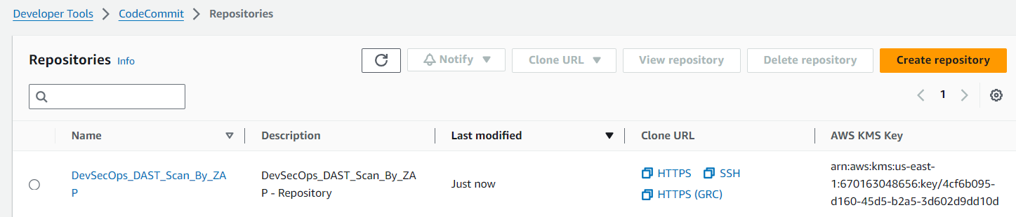

**Add buildspec.yaml and commit the changes**

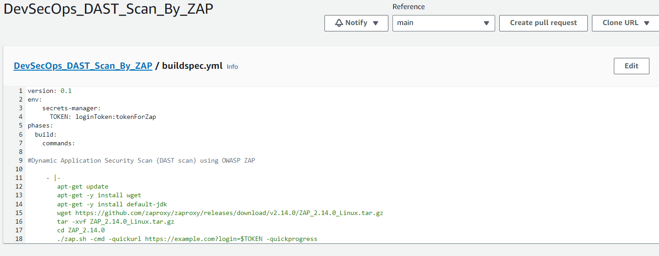

**Create a secrets in secrete manager**

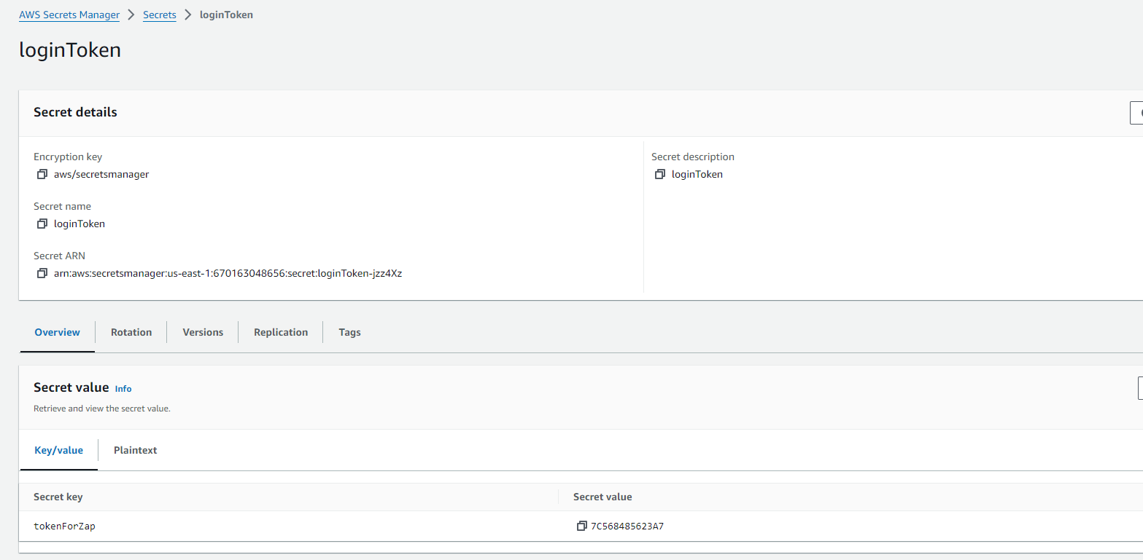

**Create the Code build:**

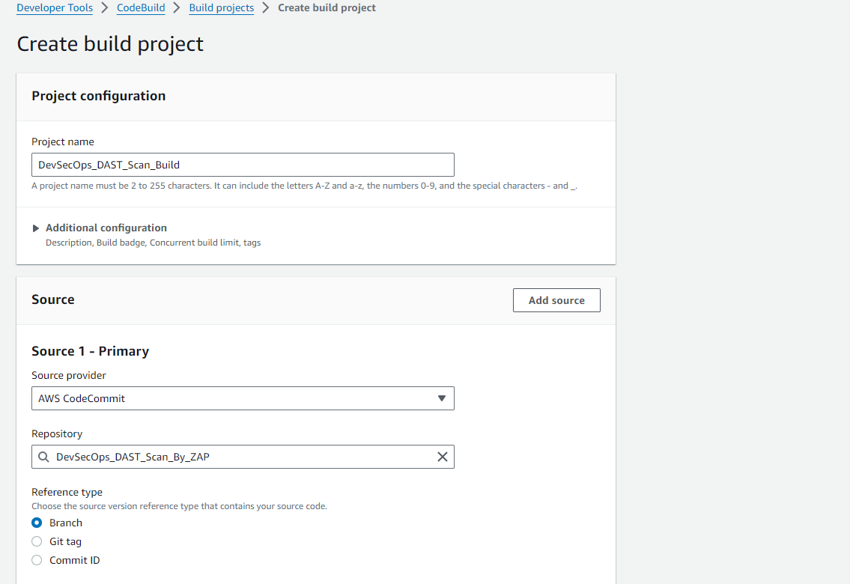

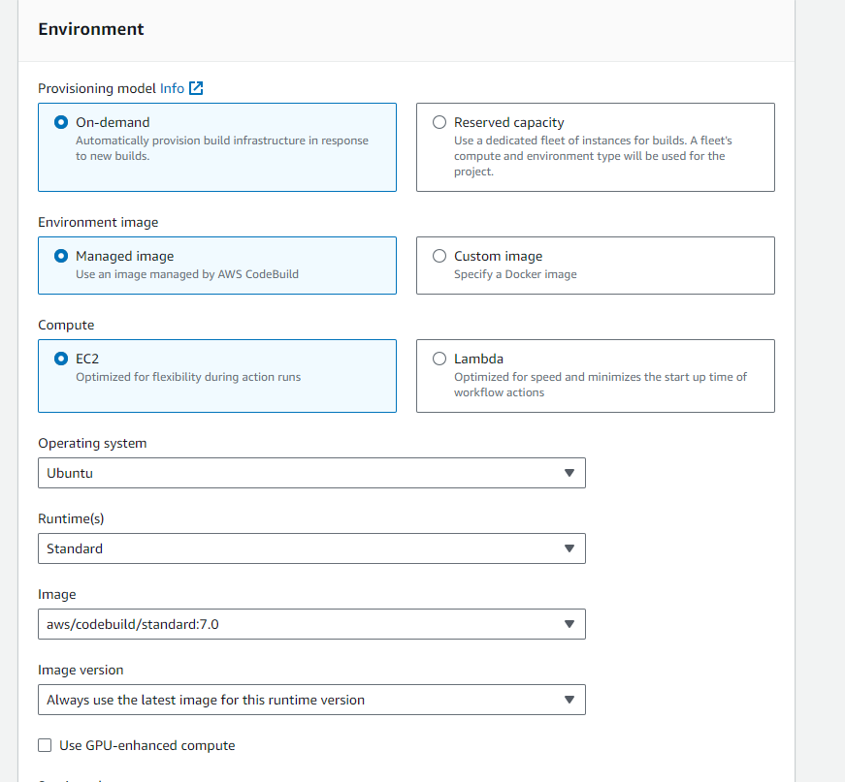

**When we start the full build – got the error.**

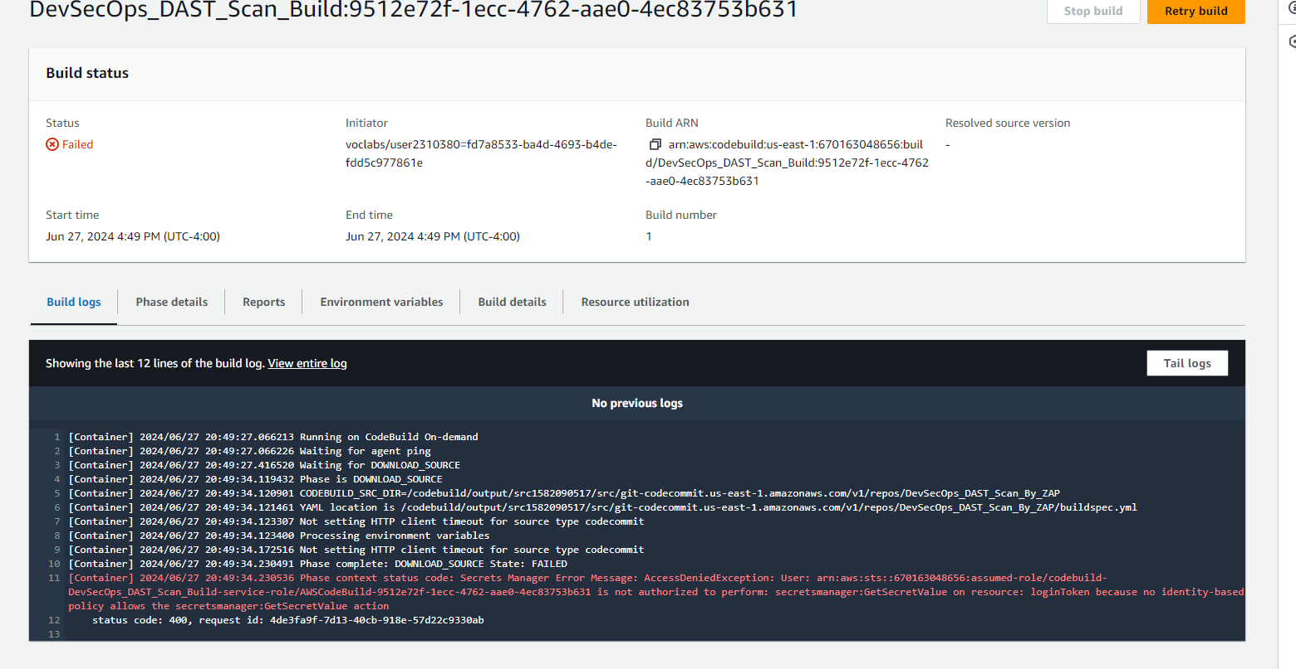

**Add secret role**

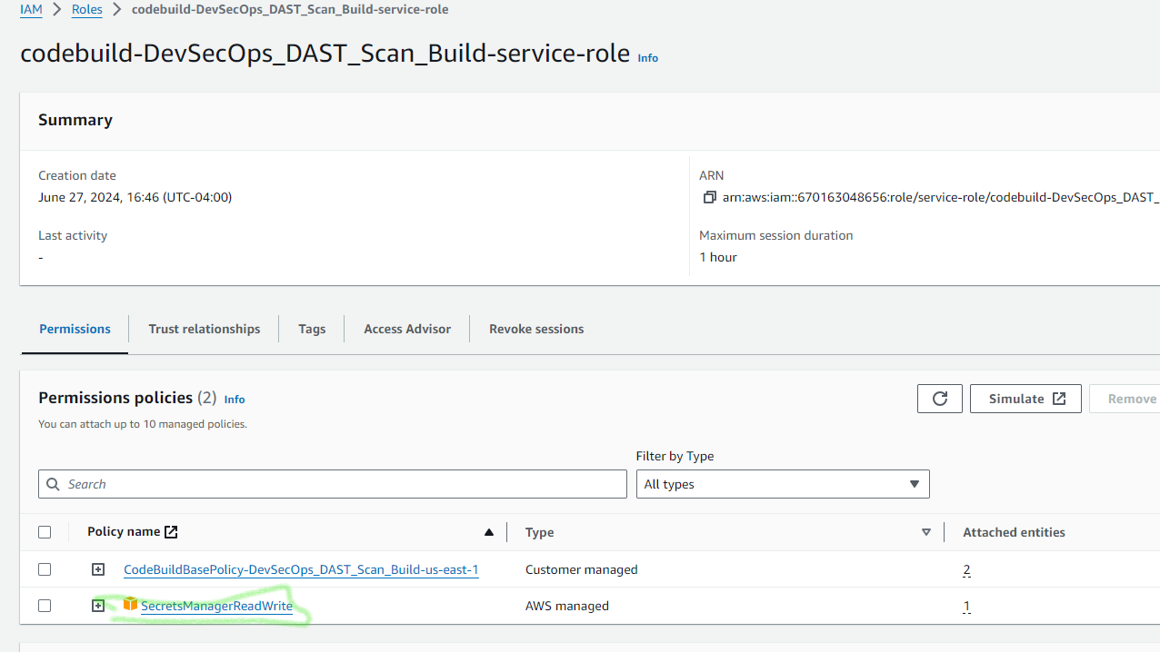

**When we restarted the Full buil – Code build was successful.**

